Task No & Title:  Unit 9 | Unit Descriptor Unit Descriptor This covers the development of basic keyboard skills using touch-typing techniques
Title: | BSBCMN108A Develop keyboard skills
Suitable for Classes: | Certificate II Business
Area: | Technology & Enterprise
Teacher: | Mr Peter Faulks
Timeline | 1 Lesson
Date Due: | Today

Task Brief:

Files Required

Items highlighted in yellow are tasks for you to complete
Items in Blue are help tips

Unit | Number | Title | Study Time
1 | BSBCMN201A | Work effectively in a business environment | 20
2 | BSBCMN202A | Organize and complete daily work activities | 15
3 | BSBCMN203A | Communicate in the workplace | 30
4 | BSBCMN204A | Work effectively with others | 20
5 | BSBCMN205A | Use business technology | 30
6 | BSBCMN211A | Participate in workplace safety procedures | 15
7 | BSBCMN213A | Produce simple word processed documents | 40
8 | BSBCMN214A | Create and use simple spreadsheets | 20
9 | BSBCMN108A | Develop keyboard skills | 40
10 | BSBCMN107A | Operate a Personal Computer | 20
11 | ICAITU013C | Integrate Commercial computer packages | 30
12 | ICAITU012C | Design Organizational Documents using computer | 50
 |  | TOTAL

Match the parts:
Function Keys, Typing Area, Movement Keys , Additional Keys, Option Keys , Application Key, CD/DVD Controls, Internet & Multimedia Keys, Numeric Keypad, Status Lights, Windows Keys, Wrist rest

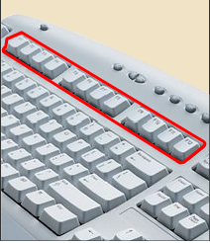 | 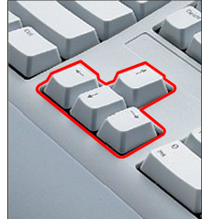
Ans: | Ans;

Ans: | Ans:
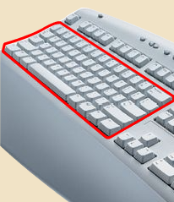 | 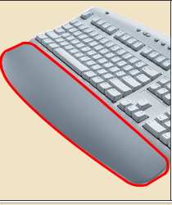

Ans: | Ans:
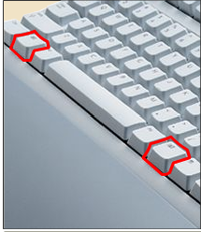 | 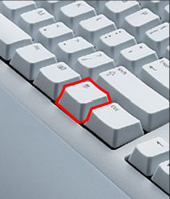

Ans: | Ans:
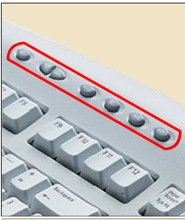 | 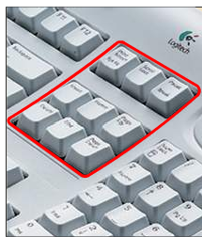

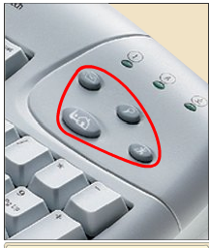 | 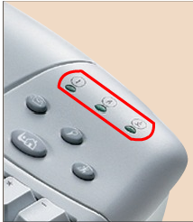
Ans: | Ans:

Ans: | Total Score
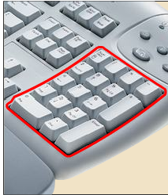

Now take the typing Test on line

http://www.goodtyping.com/default.htm

Save the work

Student Name: | Date submitted:
I declare this evidence to have been produced by me the undersigned.

Candidate’s signature:
Title of Portfolio evidence presented Enter title here
BSBCMN108A Develop keyboard skills Section 09:???
□ Outcomes from learning programs (including self-learning and online learning)
□ Assessment feedback (from a trainer or assessor)
□ Observation checklists (from a workplace supervisor or assessor)
□ Written statements or references (including workplace supervisors, community leaders)
□ Job descriptions
□ Work journal
□ Work samples
□ Finished products
□ Product descriptions or specifications (supporting the product samples included)
□ Statutory declarations
□ List others (or delete any from above not provided)
- All work submitted to be word processed and spell checked.
- There must be at least two samples of evidence for each
Element within the Unit of Competency. This is sample 1 / 2
- All work submitted must be of a high quality and meet the
requirements of the Unit of Competency.
Other evidence (List each piece):
Assessor to complete
Evidence is Valid Sufficient Authentic Current
□ □ □ □

Assessor signature: _________________________________Date: _____________
Peter Faulks, BA Soc Sci, Grad Dip Ed, Cert IV AWT
Certificate II in Business assessor/teacher
Assessor to complete

Student is declared Competent Not Yet Competent
□ □

Keep a copy of this report with your file for evidence

